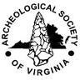
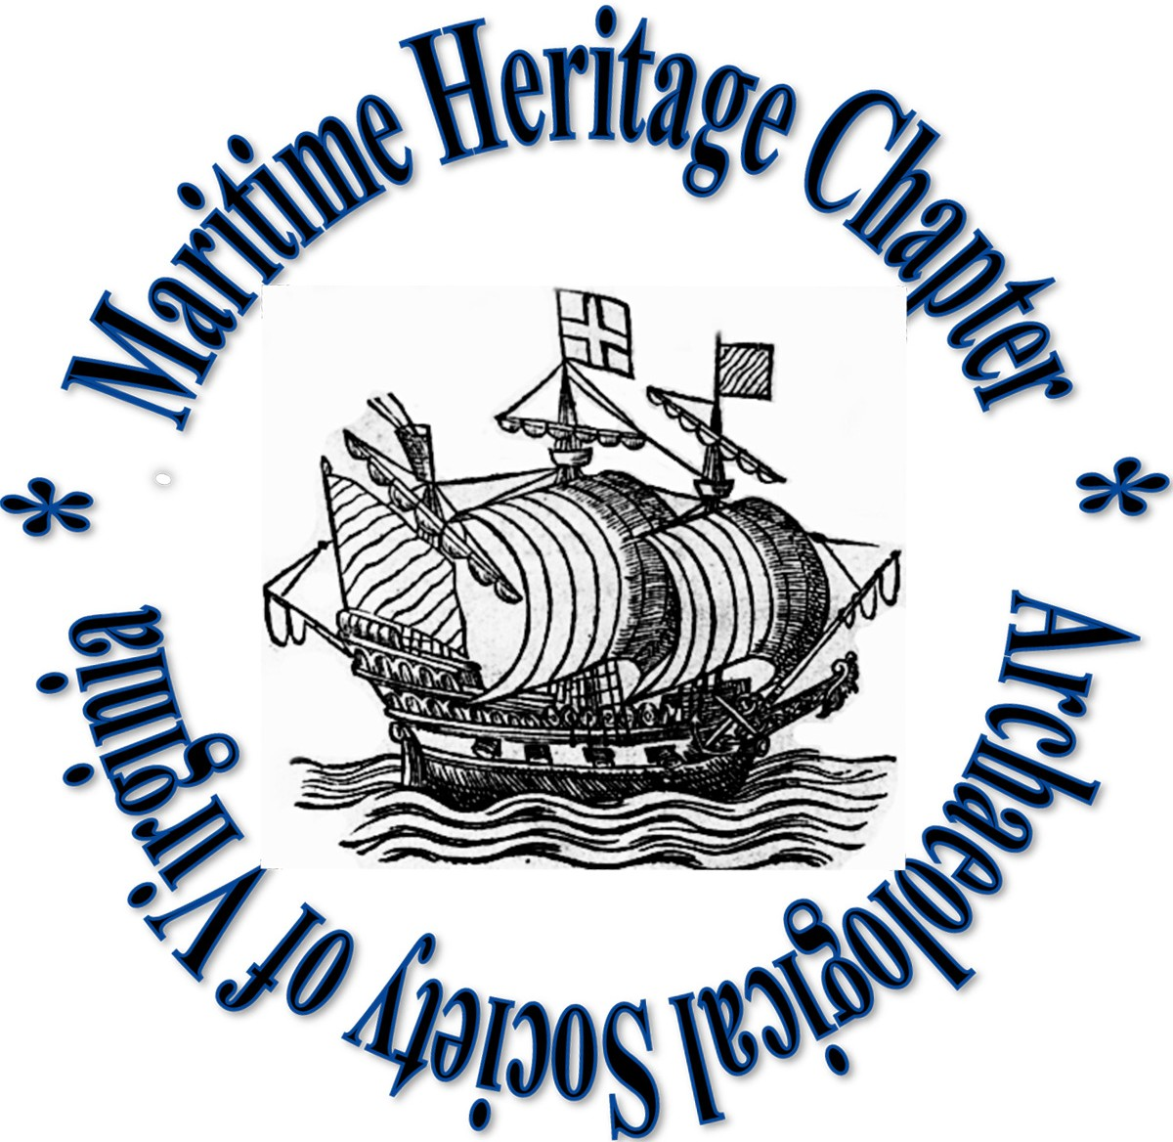
Maritime Heritage Chapter
Archeological Society of Virginia

AGENDA

Fall Meeting

24 September 2022

1:00 PM
Deltaville Maritime Museum
Deltaville, VA

- Call to Order and Welcome (Bruce Terrell, Acting President)
- Opening remarks from Bob Leboeuf, Director, Deltaville Maritime Museum
- Presentation of Monetary Donation from MHC to the Museum
- Reading and Approval of Minutes (Bob Hayes, Acting Secretary)
  - Minutes of 8 March 2022 Chapter meeting
  - Minutes of special “session” and topic meetings of MHC Officers from July and August 2022
- Consent Agenda
- Secretary’s report (Bob Hayes, Acting)
- Treasurer’s report (Rich Eilers)
- Membership report (Rich Eilers)
- President’s report (Bruce Terrell, Acting)
- Committee Reports
- Research & Projects (5 minutes max each)
- Mid-Atlantic Log Boat Registry Status (Bob Hayes)
- CSS Richmond Status (Bill Waldrop)
- Archaeological Training: Bill Waldrop on NAS Field School, Osborne Landing (15 min); discuss impact of Dave Thompson stepping down as Committee Head
- Dive Safety
- Public Education & Outreach
- Membership & Development (Vacant)
- Meeting & Event Planning (Vacant)

Old Business
  - 2022 ASV and MHC dues if you have not paid
  - Other?

- New Business
  - DHR Update: Brendan Burke
  - ASV Update: Bruce Terrell
  - Discussion on the various vacant Committee positions and efforts to get membership involved to fill them. Take nominations or ask for volunteers to fill committee vacancies.
  - Discussion and Selection of Officer Nominating Committee and Chairman to fill upcoming vacant Officer positions. Development of procedure for compiling nominations from membership to fill vacant positions and who can vote in the upcoming election.
  - Discussion and selection of date (December?) for chapter meeting to nominate elect new MHC Officers. Determine if this meeting will also coincide with possible holiday social.
  - Other Proposals, Motions and Topics from the floor
- Call to Adjourn

MHC 2022 Officers

President: Bruce Terrell (Acting)
Past President: Brendan Burke
Vice President: Bill Waldrop
Vice President: Lilli Azevedo
Secretary: Bob Hayes (Acting)
Treasurer: Rich Eilers

MHC Standing Committees
Research & Projects Committee
Bill Utley (Chair), Bob Hayes, John Broadwater, Rich Eilers
Public Education & Outreach Committee
Lisa Jordan ?
Archaeological Training Committee
Dave Thompson (Chair)
Dive Safety Committee
Bill Utley
Membership & Development Committee
TBD
Meeting and Event Planning Committee
TBD

