
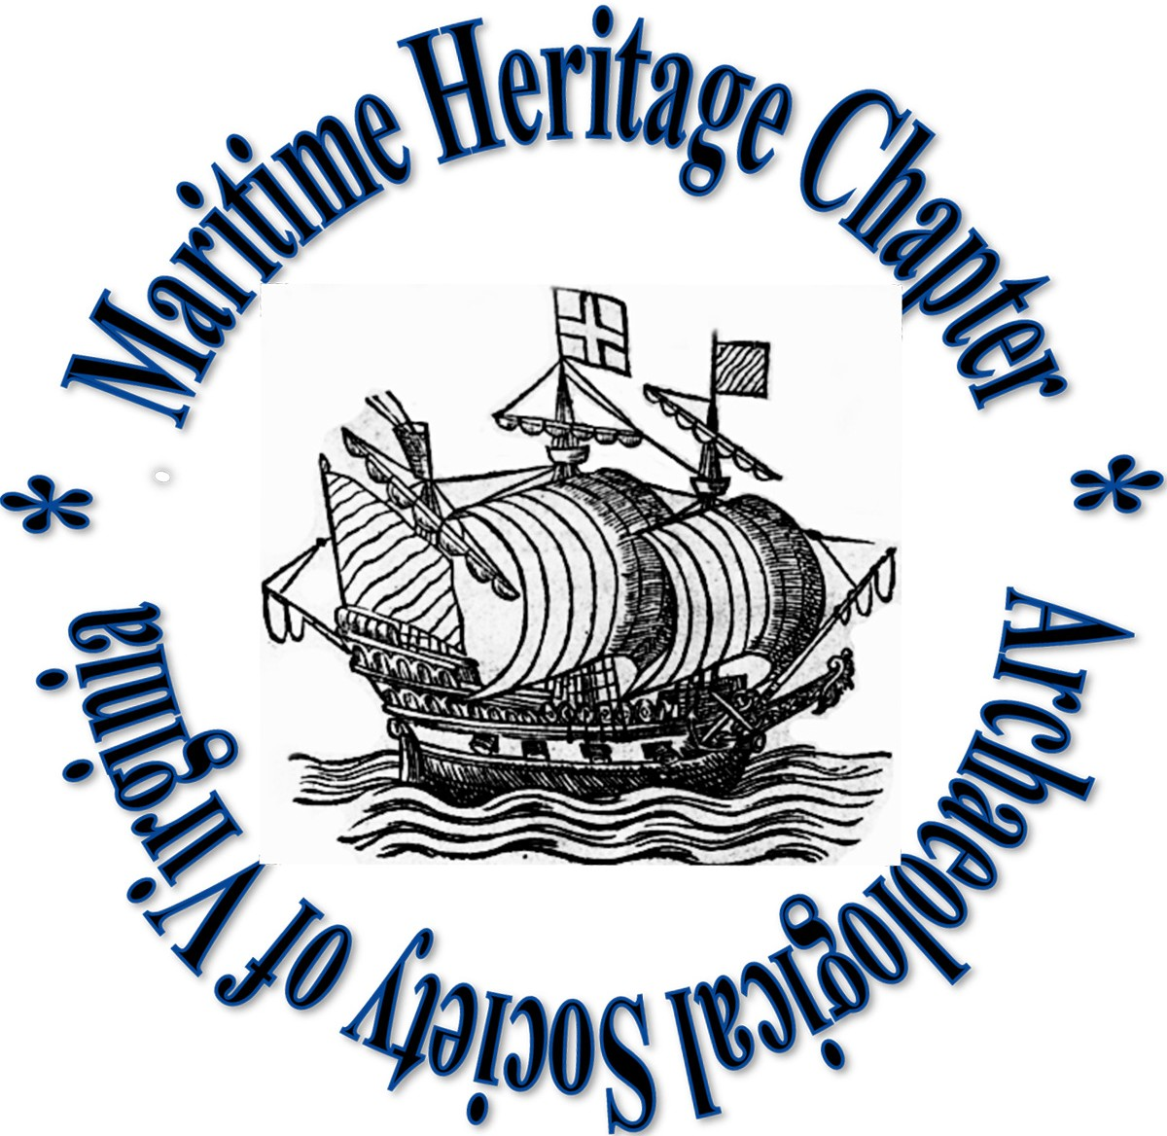
Maritime Heritage Chapter
Archeological Society of Virginia
9943 Cheathams Road
Amelia, Virginia 23002
Amelia VA 23002

D R A F T AGENDA

Winter Meeting

Tuesday December 8, 2020

6:00 pm

ONLINE PANDEMIC VERSION

- Call to Order and Welcome
- Reading and Approval of Minutes
  - June 20, 2020 meeting-Brendan amended minutes, voted on; will read later.

- Consent Agenda
- Secretary’s report (Bruce Terrell)
- Secretary’s report

- To recap, there was no October meeting this year, although the ASV held two sessions on October 17 and 24.

- Due to COVID madness we inadvertently missed the October date for nominating new officers. However, Brendan did notify membership and we are nominating at this meeting.

January 15 will be next meeting and voting on new laws as per the bylaws.

All officers should have access to Google docs folder
- Treasurer’s report (Rich Eilers)
$3228.40 - assets
25 active members
- Membership report (Rich Eilers)
d. President’s report (Brendan Burke)
- moved up next two reports:
Elizabeth Moore DHR Dir.–
- Encouraged group to lobby for underwater position, still in budget at $0; allows possibility of having program again if budget improves in future.

- Legislative mod to VA antiquities act passed in legislature making it a misdemeanor to excavate on state property on terrestrial sites;

- Riverine and coastal surveys through “Mike and Flo” hurricane program (Hurricanes Michael and Florence; must have Sec 106 review thru NPS;

- EM is on SAC for Mallows Bay sanctuary;

- DHR dealing with Confederate monument issues; Lee monument in Richmond;

- Funding from Conservation Fund for Skiffs Creek; will provide curation artifact work;

- “Archaeology of Virginia’s First People” publication was released in October;

- Stamp program tagging funded thru Threatened sites fund; working through problem, i.e. making tags, also computer-linkage issues;

- Potential new wreck in Coan River;

Mike Barber –
- Discusses nominating the Yorktown Fleet as national marine sanctuary.
- protection, management, education; community involvement
- Area includes 26 Revolutionary War warships;
- 11 have known locations;
-Summarizes HMS Betsy project
- Included in the area are Kiskiak, and heritage of York River up to West Point
- There are paleontological resources as well;
- ARPA may come into play (regarding federally owned lands;
- He asks if Does MHC want to take it on? Says there is a need for leadership.
- Brendan echoes John Broadwater admonition to focus on the big picture at this point;
- Group discussion…MHC membership agrees to continue discussion on support;
- suggests adding to existing an committee
-* John motions to consider Research and Projects committee to discuss.
Or poss. an ad hoc committee; Bob Hayes seconds; motion carries.
- Lisa volunteers to help;
- Committee Reports
- Research & Projects - Bob Hayes, Log Boat registry busy year; INA Journal article in Sept; Seay canoe in Chesterfield; canoe in Charles City co. Jamestown Yorktown committee involved; Plans for 2021 will be announced soon;

Archaeological Training - Dave Thomas – some NAS training, most participants out of area; 180 dollars for student training cards, $0 for training; next years schedule every other month a seminar; post covid higher expectations;

- Dive Safety - Covid has halted CPR training; Wants to promote DAN courses; Greg Jolley offers underwater arch courses (operates out of dive shop in NVA);

- Public Education & Outreach –
- Presentation mad by captain of USS Indianapolis; Brendan recommending John Broadwater give presentation on Apollo booster recovery;
- Lisa – disheartened by NAS response from membership; comments on chapter participation; she is coming in as ASV treasurer; advocates for putting money into NAS; Jim Tuite says MHC is NAS affiliate so we are part of it; …Move to new business…
- Training opportunities are on the website blog; Brandon, need to update blog
- John Broadwater – FB page is “Maritime Heritage Chapter of the ASV”
- Discussion about making better use of webpage and blog, FB page

- Membership & Development – on hold
- Meeting & Event Planning – on hold

Old Business
  - 2021 ASV and MHC dues are due no later than January 31, 2021
- Remind members of new dues structure
- Go over 2020 renewal/new member sheet price structure
2021 ASV and MHC dues are due no later than January 31, 2021 – due 31 Dec; Amendment 6 changed dues structure. Brendan cites; *have Brendan send new bylaws; Brendan suggestion that dues should be able to be paid through Paypal; Elizabeth suggests one payment through ASV and MHC earmarked; discussion on poss. payment methods;

  - Remind members of new dues structure
- Go over 2020 renewal/new member sheet price structure
  - STAMP update –
- Wants MHC branding on tags;
- needs training for tagging;

- New Business
  - DHR Update – Dr. Elizabeth Moore – See above
  - Yorktown Sanctuary Nomination – Dr. Mike Barber – See above
  - MHC Officer Elections
    - Floor open for nominations of slate, to be voted on at next meeting (January 2021)
Nominations – Bob Hayes nominates Brendan as pres;
Terrell will accept re-nomination as Secretary taking leave through summer, Lisa will cover duties during absence.
- Lisa nominates Lily to be 2nd VP;

  - 2021 schedule – Due to COVID, 2020 schedule moved to 2021
  - Topics from the floor - Lisa motions to put enough funding aside every year to cover NAS membership fee;
- consider how many years til we need to reup – full amount? Or incremental every year to add up to new fee ($900?)
- how those funds come in?
- ask Dave recommendation – must pay nominal amount per seminar;
can Dave collect NAS fees?
- Motion – MHC asks as 1. affiliate we use Dave Thomas’ Portunes as a contractor for providing training; 2. put sufficient funds aside each year to cover 5 year cycle of NAS license to cover any deficiencies;
(send to Dave for language clarification);
*Membership votes – Motion passes

- NAS presentation on CSS Richmond, Mike and Bill polishing presentation;
- Bob Hayes – commends Lisa Jordan’s work for MHC –
Welcome Josh Daniel

  - COVA update – adding to health and safety a maritime component;
Near water and under water; Brendan sending draft to membership;

- Call to Adjourn: 8:14

