
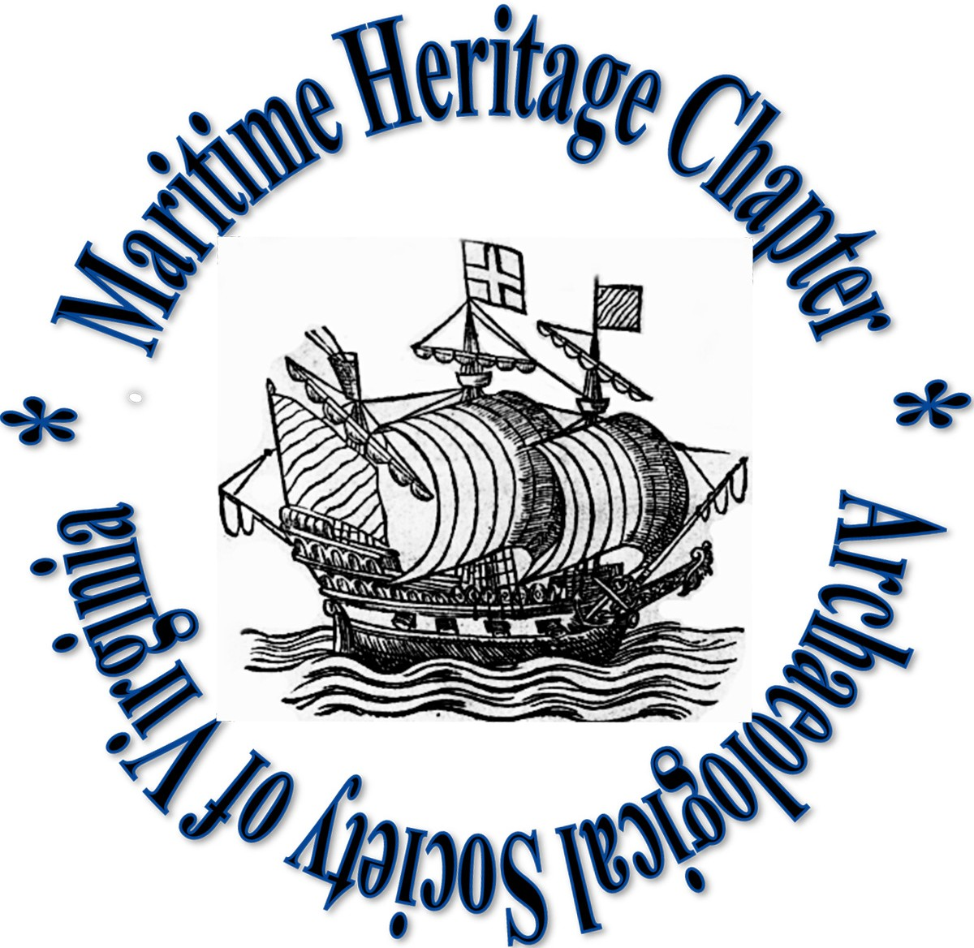
Maritime Heritage Chapter
Archeological Society of Virginia
9943 Cheathams Road
Amelia, Virginia 23002
Amelia VA 23002

D R A F T AGENDA

Winter Meeting

Tuesday January 26, 2021

6:00 pm

ONLINE PANDEMIC VERSION

- Call to Order and Welcome
- Reading and Approval of Minutes
  - December 8, 2020 meeting
- Consent Agenda
- Secretary’s report (Bruce Terrell)
- Treasurer’s report (Rich Eilers)
- Membership report (Rich Eilers)
- President’s report (Brendan Burke)
- Committee Reports
- Research & Projects
- Archaeological Training
- Dive Safety
- Public Education & Outreach
- Membership & Development
- Meeting & Event Planning

Old Business
  - 2021 ASV and MHC dues are due no later than January 31, 2021
  - STAMP update
  - 2021 Elections
    - Secretary –
    - Treasurer –
    - Vice President –
    - Vice President – Lillian Azevedo (nominated 8DEC2020)
    - President – Brendan Burke (nominated 8DEC2020)

- New Business
  - DHR Update
  - 2021 schedule
  - Topics from the floor
- Call to Adjourn

MHC 2020 Officers

President: Brendan Burke
Vice President: Lisa Jordan
Vice President: Bill Waldrop
Secretary: Bruce Terrell
Treasurer: Rich Eilers

MHC Standing Committees

Research & Projects Committee
Bill Utley (Chair), Bob Hayes, Rich Eilers
Public Education & Outreach Committee
Lisa Jordan (Chair), Lisa Tuite
Archaeological Training Committee
Dave Thompson (Chair)
Dive Safety Committee
Jim Tuite (Chair), Bill Utley
Membership & Development Committee
?
Meeting and Event Planning Committee
?

